[2012]
British Columbia Youth Adult Committee

By Dani Cooper and Elijah Marret-Hitch, with contributions from all BC YAC Members

Table of Contents:
1…Existential Foreign Policy and World-Wide Alienation
2…Reflections on the Occupy Movement by an Outsider
4…An Explorers Guide to UBC
6…Hunger Games- A Critical Review
8…The Do’s and Don’ts of Gender Identity
9…Famous Unitarians You Probably Never Knew About
10…Uncovering the Web- UU Youth Testimonial
11…Upcoming Events
12…How to Join the BC YAC (for Youth and Adults)
14…Contact us!
15…BC YAC Bios

[THe YEARLY MURMUR]
The British Columbia Youth Adult Committee yearly newsletter. The purpose of this newsletter is to encourage spiritual and personal growth, raise awareness around social justice issues, advertise UU youth events, and provide personal testimonies and articles written by Unitarian Universalist youth of B.C.

FAQ’s:
What is the BC YAC?
The BC YAC (Youth Adult Committee) is the group that makes the important decisions in BC for all you crazy youth. We decide themes for the regionals, what trainings to hold and host, and what work needs to be done. We also keep in contact with PNWD Youth Empowerment Services. We’re here to answer any of your questions and concerns, and are equipped to deal with big issues.
Why should I care?
BC YAC is the medium to get your voice heard. If you want to meet other Unitarian Universalist Youth, learn some silly games, have some deep conversations, and at the same time live your Unitarian Universalist values, the BC YAC can get you in touch with people, and help you get to events where that stuff happens. UU’s are AWESOME, UU youth are even AWESOME-ER, UU youth leaders are SO CRAZILY AWESOME WORDS CANNOT DESCRIBE.
To learn more visit www.bcyac.weebly.com or email us at bcyac@yahoogroups.ca

Existentialism?
Don’t
even get me
started.
Existential Foreign Policy and World-Wide Alienation
By DANI COOPER
Newsletter Editor
In today’s society, an existentialist world philosophy has brought about many changes in global interactions. An absurd, immoral, and disconnected world has brought world issues into a dire and delicate state where a lack of recognition, responsibility, and an isolationist approach to life has resulted in the deterioration of less fortunate nations, and the establishment of systems where divides are upheld and widely accepted by the general population. These divides can be seen across cultures, in the neighbourhoods of our cities, and in the countries relations to each other. Everyday life has become the active pursuit of free will, at the cost of the nations around us.
The first stated absurdity is the unnecessary and stoppable waste of resources. With the ever developing technological field, elements of our society such as inclination to gas-powered cars, chlorine bleached non-recycled paper, both of which contribute highly to chemical pollution, should be long outdated and beyond consideration when considering the massive flow of environmental advocacy messages. This is not a concentrated problem either, across the world in some of the most advanced societies where technology to limit the waste of resources, saving money and materials, should and could come easily, it doesn’t. This disconnection to the demand of the natural worlds respect on a global scale is preposterous, as by recycling materials the benefit could be seen globally. Yet the lack of

moral dilemma and indifference to these consequences has provided the world to means to casually accept these circumstances as inevitable and make no effort to change them. Meursault from The Outsider by Albert Camus reflects this indifference, “Since we're all going to die, it's obvious that when and how don't matter.” In today’s world we reflect this statement with our recognized compliance.
In addition to that, our drives to fulfill our wants and desires are magnified against the stark contrast to the visible results of this negligence. The developed world has become so inwardly focused that the irrational greed we experience has left other nations in unfavourable positions. With the prevalence of starvation, the lack of democratic rule, and the destruction on the very soil on which we stand, the paradox we display becomes evident. Through carelessly immoral actions, the distribution of food and liberties has become irrational in its systematic alienation of those deserving and those not deserving. This detachment of the members of a society from each other and the world around them has resulted in the unsympathetic viewing of others.
Certainly, this unsympathetic view of others has created global divides between countries. Notably the United States of America is often seen as upholding an existentialist point of view, and the divides it has created are plentiful. Loudly promoting the views of equality and free will, the United States has repeatedly spoken against communism. The U.S.A. thrives on the belief that the only real values in life are produced in the context of striving and suffering, a utopia would destroy human values. Unsurprisingly, America is also known for its arrogance and general ignorance of responsibility for its choices. This mind set has led to America contributing massively to global pollution, enforcement of mantras of selective moral disregard, and promotion of insensitive freedoms such as resource waste. It’s apathetic approach to global needs and communication has resulted in an appearance of callousness towards the outside world.
Conclusively, the existentialist world of which we are a part has placed value on isolation and separation. In The Outsider by Albert Camus, the main character Mersault shows how disconnected and absurd our society has become in his description of his experience with the justice system, “...he went on like that, saying ‘I’ every time he meant me...It seemed to me that it was just another way of excluding me from the proceedings, reducing me to insignificance and, in a sense, substituting himself for me.” This quote shows that even on a smaller scale, the effects of global existentialist philosophy can be noted. This distinct alienation and focus on the individual wants and desires of the world’s citizens has led to the despair and lack of personal responsibility we can observe in foreign policy today.

Reflection on the Occupy Movement by an Outsider
By DANI COOPER
Newsletter Editor

Taking a deep breath and a step back from my initially judgemental opinions of the Occupy movement, I can now say I was incredibly wrong. I saw the movement as a directionless force with no impact, a passing spirited outcry that would soon be silenced. Now, I can see Occupy was so much more than that, and I wondered if anyone had really taken the time to learn what it was really all about.
Occupy was born from fire, literally. Mohamed Bouazizi, a Tunisian merchant, had finally had enough of governmental corruption affecting his livelihood and set himself on fire. This fire ignited the Arab world, inciting demonstrations and riots throughout Tunisia in protest of social and political issues in the country. The movement spread as the Arab Spring, which toppled governments in Tunisia, Egypt, and Libya, and continues to reverberate throughout the world. A global democratic movement was born of the people, fighting for their freedom.
Perhaps the most impressive thing about the movement is the diversity of people it’s causes umbrella. It is one of the rare movements that brought together peoples of all races, people of all ages, religious groups, ethnicities, and classes together for a common good. It hit 95 cities, across 82 countries, and over 600 communities in the USA alone. In our individual-based society Occupy has been a force to be reckoned with, breaking down barriers and opening the door to a flood of unanswered questions, passionate discussions, and story-telling. Even more impressive is the fact that Occupy, despite the incredibly diverse groups of people it gathers, remained a mostly peaceful protest. This is why the incidents of police brutality, videos of a police-state at work, brought forward such a swell of emotion; a sense of urgency and righteousness echoing throughout North America.
While I have been wasted my time debating the legitimacy of the movement, I have missed the point entirely. Glaring inequities are a harsh reality in this class-driven society where the poor become poorer and the rich become richer, where government is dysfunctional and misrepresentative of the wants of the people, where the projects of Vancouver paradoxes the homes of millionaires barely ten blocks away. We can choose to either add to the momentum of this movement of hope, honest reflection, and heated debate, or let the embers dwindle and then finally extinguish and leave our corrupt society still standing to fight another day. Perhaps the first step is to ban corporate money in the electoral process, arrest financial fraudsters responsible for the 2008 crash, and investigate and prosecute corruption in politics; all of which are avid contributors to the demise of democracy. The movement’s voice was clear to those who listened, “We want more and better jobs, more equal distribution of income, an end to the influence of corporations on government, and an end to tax evasion by wealthy firms. Is justice too much to ask?”
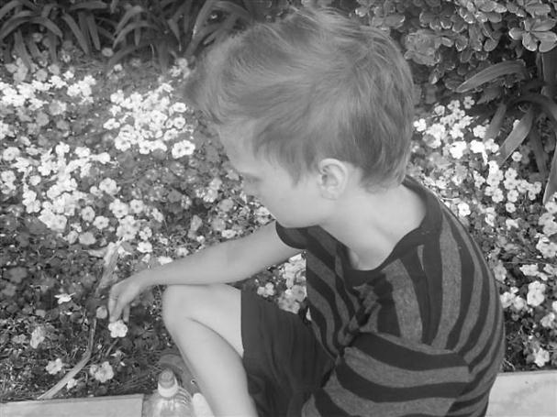

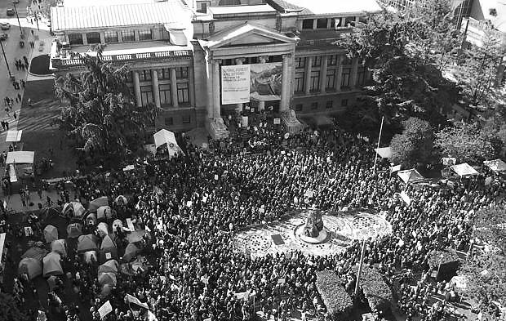

Occupy Protests in Vancouver, directly above and left.
Top right picture author: Dani Cooper
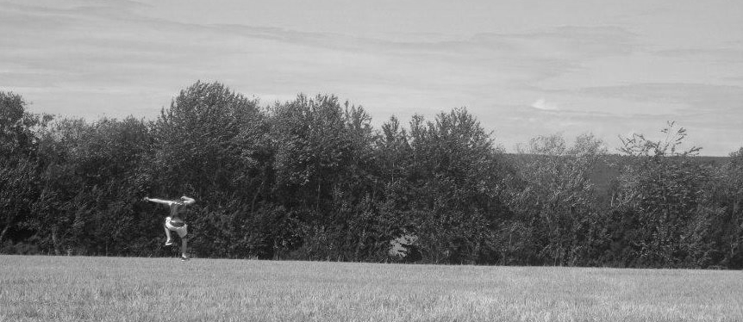
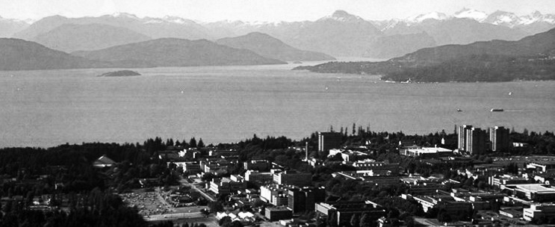
An Explorers Guide to UBC
By DOUGLAS ENNENBERG
Co-Chair
UBC, in upper right. Left Picture author: Douglas Ennenberg

I’ve been going to UBC for a whole 8 months now, and I’ve got to say, what I’m going to remember most from that place is not the classroom (maybe some facts and concepts), not all my classmates (maybe the professors) but the land, where I spent my time thinking, away from all that learning. I’m going to take your hand and guide you to some of the best, most secluded areas of campus. First, get yourself a map of UBC. Online is fine, but it’s better have a printed copy you can make notes on and take with you when you find these places for yourself. Good. Now, take a breath. Let’s go.
First, let’s hit the Cliffs. To do that, you’re going to need to locate Place Vanier Residence on your map. To the top-left of that, you’ll see a little road poking out and connecting to Marine Drive. What the map doesn’t show you is that that little road goes right through the forest in the form of a gravel driveway (it also doesn’t show you the big black gate, which you may or may not have to climb to get out of Place Vanier). Take that driveway until you come upon a small dirt path to your left. Take that path, it winds between trees and ferns, and you will come to a fence that says something about danger loose dirt, warning cliffs, etcetera, etcetera. Pff. You’re going to slip yourself under or over or between the rails of that fence, just down a little slope, peppered with rocks and roots, and in a second you’ll find yourself gazing out over an ocean as blue as your first lover’s eyes. Realize how many islands you can see across the water. There are soft dusty roots you can sit on, and using them to prop up your backpack means it won’t roll down and slide off the cliff! You can see the mountains to your right, and if you tiptoe down to the edge, you’ll find a bird’s eye view of Wreck Beach is enough to make you want to get down there yourself and greet the natives. I strongly suggest you go to Wreck Beach if you have not been. I know the whole ‘nudity’ thing might sound weird and intimidating, but it’s not, and you don’t even have to take your clothes off. But you may as well take your shoes off to dig your toes into the sandy beach and to run along all the logs. Wreck is honestly the most beautiful beach in Vancouver. There’s a steep dirt path that leads down from the Cliffs, takes you all the way to Wreck, but don’t run so fast down it that you miss all the viewing areas on the way down; one tree is known as God’s Hand, see if you can find it. And you’ll know if a blackberry is just perfect if, when you pull it off the vine, you a little black juicy kiss that you have to lick off your finger. And thumb
Next I have to tell you about Nitobe Garden. It’s just above Place Vanier on your maps, so head back up University Boulevard and left, past the cherry trees, the intricate Asian statues of protective dogs, the parking lot, until you find the 5 rocks, shipped from the province where Confucius was born, and each marked with one of the five virtues upheld by the man himself. Meditate on their advice as you walk down the hill and into the Nitobe Garden. The first thing you are faced with is a choice. Right or left? Don’t decide until you get there, take the Daoist approach and let the moment guide you. Your choice will be made for you by the ripples on the pond, the hue of the moss-hills due to rain or sun, which of the many green trees catches the light just right to catch your eye. The pebble path will take you past the gazebo, over the river once or twice. Feel free to go sit by the pond and count the carp.
But you’ve got to leave eventually, because you haven’t seen the MoA. So go check it out
, it’s on your map. Once you’re sick of relics of human history, head on out the front doors, and take a right. Follow the side of the building as close as you can by the path, which really is not all that close, and find the white beach. You may have seen it from inside. One huge window-wall looks out on the pond, overseen also by 2 or 3 great, tall totem poles, and edged by a hill. Now that you’re looking in from the outside, you can walk along that hill. Stay to the left of the top. Get to the corner and take the path down the edge. Cross the little road and hop down into the garden. Cecil Green park hosts rolling lawns, vibrant and fragrant flowers, lush green trees and other plants, a pond or two of its own, and the best part is that I can guarantee you that you, the flora, maybe a couple gardeners, and maybe one other little group that I promise will stay chill and you won’t even see them because they’ll be in a totally different section of the garden will be the only ones there, and the grass will have been long enough to be roll in comfortably, and not cut so recently that all the severed bits get in your clothes. Yay! you say, we can play steamroller! Look all around that garden, find the patio set, find the “upside-down tree,” smell the flowers and there’s honestly not really much else to do there.
But that’s sort of the point of all these places; I wanted you to know about them because you can go there to chill. Or read, or study, or have a nap, or just to see it all. I’m a firm believer in the importance of one’s environment. These are just a few examples of great places at UBC, a start to your collection. There are so many more places you’ll have to find on your own, the campus is littered with spots worth visiting. I believe that in even the dinkiest of buildings on campus must house at least one couch, usually more, and I am proud to say I have hunted down some elusive couches, though many still remain wild and free, for now. Try the longhouse (free tea and couches), the roof of the SUB (only if it’s nice out), the library gardens (benches), the libraries (and all their own secret nooks and crannies). Find the whale, the Rose Garden, the Art Gallery, the Buchanan courtyards. There’s a parking garage near Nitobe whose top floor is always empty.
Then, before you go home, if you’re reading a book in the shadow of the clock tower and you notice the sun happens to be hanging around near the horizon, take yourself back to the cliffs and you’ll see the sunset. Miles of ocean, piles of islands, the mountains split, half-dark, half-light, and the whole spectrum of colours dropping and rolling slowly along the spectrum until you see the last spark of the sun wink out. But then again, you’ve seen a sunset before, right?

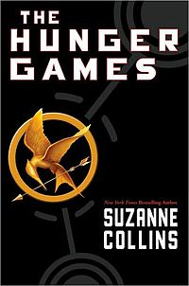
The Hunger Games- A Critical Review
By KAYLYN OLYNYK
Co-YAC Social Action Coordinator (SAC) and Technological Advancement Squad Leader
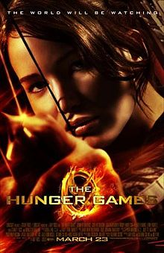

Photos from left to right: Hunger Games Book Cover, Author: Kaylyn Olynyk, Hunger Games Movie poster

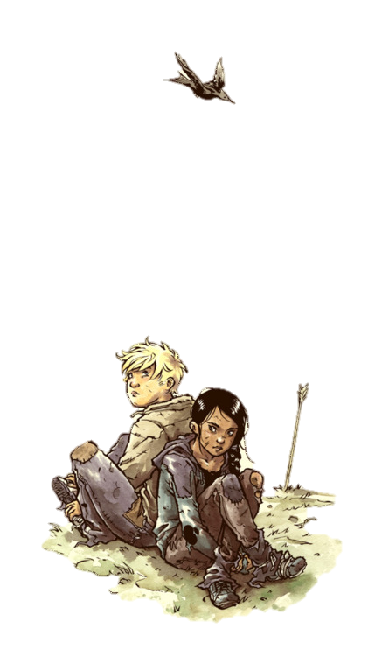
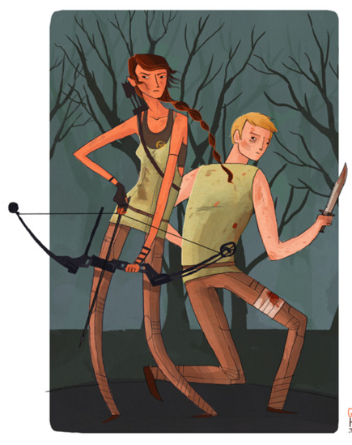
For those who aren't following the latest hit in Young Adult literature, The Hunger Games is the story of Katniss Everdeen who lives in a dystopian future world where “every year in the ruins of what was once North America, the Capitol of the nation of Panem forces each of its twelve districts to send a teenage boy and girl to compete in the Hunger Games. A twisted punishment for a past uprising and an ongoing government intimidation tactic, The Hunger Games are a nationally televised event in which "Tributes" must fight with one another until one survivor remains. Pitted against highly-trained Tributes who have prepared for these Games their entire lives, Katniss is forced to rely upon her sharp instincts as well as the mentorship of drunken former victor Haymitch Abernathy. If she's ever to return home to District 12, Katniss must make impossible choices in the arena that weigh survival against humanity and life against love." (Lionsgate)
Katniss Everdeen, the protagonist of the books, is a well-written and complicated character. Author Suzanne Collins writes her in a relatable and believable way, and avoids many of the problems so often seen with female characters. The romantic aspects of the story don't overshadow the rest of the plot, which is great to see in a culture obsessed with reducing women’s stories to tired romantic comedies and “get the guy” narratives.
Compassionate and empathetic, Katniss is shown having emotional reactions appropriate to her sometimes traumatic experiences, and is allowed to be afraid, sad, and angry. Perhaps one of the most refreshing aspects of the film adaptation was that Katniss is not sexualized or objectified at all. This in itself is a triumph.
Katniss’ outstanding qualities are especially important when compared to the rest of our popular culture, where so often the "strong female character" glorifies violence and doesn't show much emotion at all. The Hunger Games film takes a break from this tired trend, as Katniss neither enjoys violence nor is an emotionless robot. In her case, emotion is written as a strength instead of a weakness, and the film takes time away from the action to show her living a whole spectrum of emotions. Jennifer Lawrence's performance as Katniss is incredible, and proves that a woman can easily lead an international blockbuster hit.
While the book and film are a tremendous achievement for the most part, there is one major shortcoming that must be addressed. In the book, Katniss is described as having "olive skin" and "straight black hair", but the casting call for the starring role did not reflect this. The casting call specified that only "caucasian" actors could audition. These kind of actions have serious consequences that extend far beyond this particular film franchise. This is a frightening trend in our society, where it’s still incredibly difficult for people of varied races to land leading roles and to be represented fairly and equally. However wonderfully Rue and Cinna - important multi-racial characters - are portrayed in the books and movie, it doesn’t excuse the whitewashing in the casting call for Katniss.
Even with the exclusion of women of multi-national ancestry from the leading role, the film manages to be one of the best movies to portray women and people of multiple races in gender and race non-specific circumstances - as Katniss, Rue, and Cinna’s experiences in the book and film aren’t centered around them being women and/or people of multi-racial heritage.. They are given ample screen time to be shown as relatable characters and genuine human beings. I hope that the discussions sparked by The Hunger Games will open the eyes of the audience, and perhaps lead to improvements in the world of film and television for women and people of varied races alike.
Of course, the Hunger Games would be nothing if it weren’t for the readers who cared about it in the first place. We, the observers, are the ones who decide what we want to be watching, and it’s our responsibility to do so in a way that reflects what’s truly important to us.
For more information, check out FeministFrequency.com for an in-depth analysis of the books and film, in a two-part video series created by Anita Sarkeesian.

Image Credit: Mooncalfe.Tumblr
Image Credit: GingerHaze.Tumblr
The DOs and DON'Ts of Gender Identity
By Kaylyn Olynyk, Co-YAC SAC and Technological Advancement Squad Leader

Gender is complicated - it’s a part of your identity and your sense of self. It’s one of those things where you can’t know what anyone else is experiencing, which is why it’s so important to not assume things about others. Gender is more than male or female, so much bigger and more complex. It can be confusing to some, and this ignorance can lead to some pretty major problems. But there’s good news! You don't have to know everything about gender to be able to treat people with respect!
Here's a few basic tips:
DO ask someone what their preferred pronouns are if you’re not sure.
DO try to use gender neutral pronouns when you're uncertain about what to use (example: My friend Alex is awesome! They rule! I love them! I love their hair today.)
DO use gender neutral words when talking to a group. Instead of ladies and gents, try folks, everyone, colleagues, friends, etc. Get creative!
DO apologise if you screw up someone's pronouns, and then move on.
DO look for further information online, or at your library.
DO respect people's boundaries. They might not want to talk right now.
DO be open minded and willing to try to understand.
DO keep your Unitarian Principles in mind when interacting with people anywhere on the gender scale
~
DON’T use ‘it’ as a pronoun, unless someone
specifically asks for you to.
DON'T debate someone else's gender - that's their
business.
DON'T use words or names that could be offensive to
some people.
DON'T use the wrong pronouns on purpose, no
matter the circumstances.
DON'T go on the defensive when someone calls you
out. Listen to them!
DON'T think that pronouns or identities are
permanent. They can change, and if they do, it
doesn't mean they're any less valid.
DON'T forget to treat everyone with love and respect.
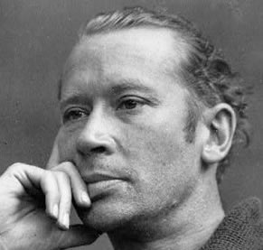
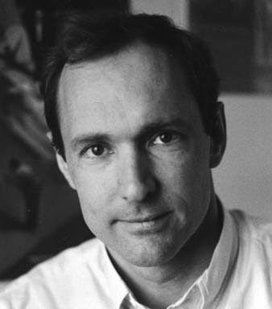
FAMOUS UNITARIANS
-You Probably Never Knew About-
E.E. CUMMINGS
-Poet and Painter-
TIM BERNERS-LEE
-Inventor of the World-Wide Web-

GARY GYGAX
-Creator of Dungeons and Dragons-
CHRISTOPHER REEVE
-Actor; best known for role as Superman-

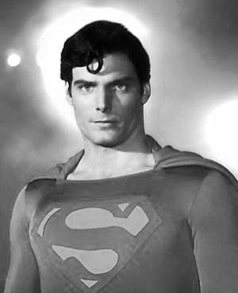
RANDY PAUSCH
-Author of ‘the Last Lecture-

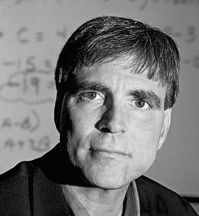

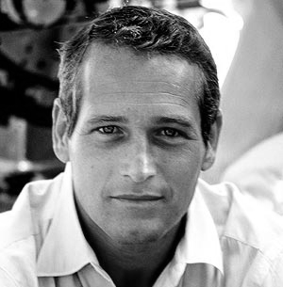

PAUL NEWMAN
-Actor/Director/Producer best known for Butch Cassidy and the Sundance Kid-

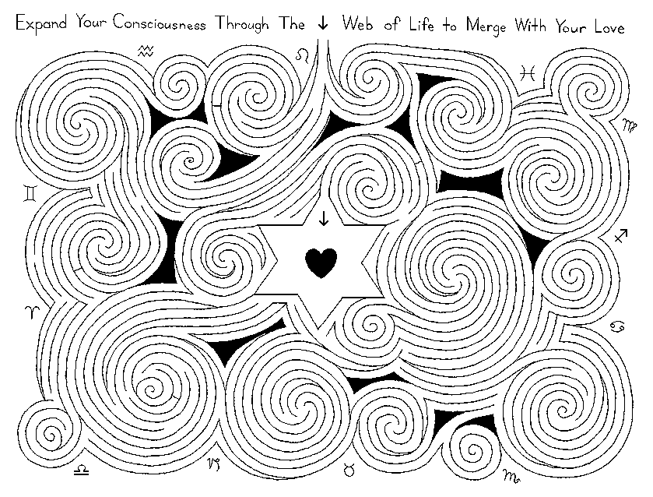
Uncovering the Web
By ZOË BRIMACOMBE
Scribe
Arguably, our whole lives are spent in search of our identities. We find activities, beliefs and people that begin to fill us up with a sense of self; slowly discovering the meaning of our own life. For me, Unitarian Universalism and the community that surrounds it is a major piece which allows me to explore my own beliefs and to express my values among like-minded, accepting people.
My experience with the UU faith began before I was born, when my parents were married by a Unitarian minister. Neither of them was practicing any set of beliefs at the time, so the non-denominational environment allowed them to plan the wedding without the added level of a religion they don’t practice. Since then, my family has been attending our church regularly and I’ve participated in children’s programs, O.W.L.S. courses, junior youth and finally (and most excitingly), youth group. My youth group is a mosaic of vibrant people, many of which I have known my whole life. Each Sunday morning finds us cuddled on the floor of our orange sponge painted youth room: laughing, talking, and (occasionally) having ridiculously deep discussions. The safe, supportive space forms a structure from which we can grow and flourish, and that we do. However, beyond the group environment lays my individual search for meaning and identity. At times, this can feel like fumbling in the dark, but my congregation environment has been a metaphorical candle.
It’s only more recently, through my involvement with YAC and my attendance at cons, that I’ve begun to really feel the 7th principle (Respect for the interdependent web of all existence of which we are a part) as a reality. Up until now, I regarded this statement as a nod to our mother earth, which I suppose it is in a way, depending on your interpretation. What I’ve discovered is that this principle relates back to my personal beliefs beautifully, in that I believe in connections between human beings on a higher level than what we perceive and I have confidence that there is really energy within us that we pass on to others; constantly recycling. The past year or so has been a time of discovering those connections and of consciously forging new ones. I’ve nestled myself into the communities of cons and the YAC, examining the common mindset of all those around me. Astounding me further is the way we can all be so completely individual and unique, yet find a way to complement one another flawlessly, as if completed by those around us.
Unitarian Universalism, to me, is all about the exploration of belief, self, and community. As I continue on my journey to figure myself out, I know I will always have the support of the faith and of the people within it. I am only beginning to see the strands of this web I’m woven into, but I know that it holds me up just as much as I pull my own weight, and I know that I will never lose sight of myself and my place within this unbelievable community.

UPCOMING EVENTS

UUA’s Justice GA- June 19-24
Where: Phoenix, Arizona
What: General Assembly (GA) 2012 will be a gathering with multiple ways of engaging in justice work for people of all ages. Joining with the people of Arizona, we will worship, witness, learn and work together. We will leave General Assembly grounded in our faith, energized for justice and with resources to bring this work home to our congregations.

CUUL School WEST- July 12-15
Where: Calgary, AL
What: CUC run multi-gen leadership camp recommended for youth age 16+ including work on Canadian UU contextual theology, team dynamics, and congregational wellness in an intentional religious and worshipping community.
Goldmine PNWD- July 22-28
Where: Bremerton, WA
What: An intense six-day school for youth where you will: develop your personal creed, deepen your knowledge of Unitarian Universalists’ challenging religious heritage and values, expand your skills for growing healthy groups, explore paths of worship, hone leadership skills so you can better heal our world, and learn to be a better leader and communicator. Registration forms/more info at: http://library.pnwd.org/documents/GoldMine%202012%20Application.pdf

Goldmine CUC- July 29-Aug 4
Where: Toronto, ON
What: See Goldmine PNWD, except this will be an intensive seven day school. Registration forms/more info at: http://cuc.ca/youth/goldmine-youth-leadership-school/

OPUS- Aug 8-12
Where: Unicamp, Honeywood, ON
What: The annual spiritual retreat of the Continental UU Young Adult Network. For those 18-35, this YA conference is an “intentional community of seekers exploring religion, social justice, and diversity.” For more info and registration forms: http://connectuu.com/events.php?action=view&event_id=1264

BC RFG- October
(location and dates TBD)
What: An intergenerational gathering focused on providing youth with an occasion for spiritual deepening and leadership development. A chance to connect with other BC youth, share ideas and passions, and make life-long friendships. For more info stay posted at www.bcyac.weebly.com

PNWD Fall Con- Oct 26-28
Where: Randle, WA
What: The annual fall conference of the PNWD region for youth, focused on providing an occasion for spiritual development and building confidence in youth leaders. A chance to connect with other youth from both Canada and the USA, share ideas and passions, and make friendships.
HOW TO JOIN BC YAC!
-And subsequently become rich, famous, and handsome-
I know, now that you’ve reached the end of this newsletter you’re thinking, “Wow, these youth are so charming, vibrant, interesting, and amazingly good-looking. I wish I could be like them!” Guess what, you can, it really is possible!
The mission of the BC YAC is to strive to promote youth empowerment, validate the role of youth in congregations, and connect all youth and youth leaders in BC to each other and the greater UU movement. If you have a deep connection to being Unitarian Universalist, and the desire to step up into a greater leadership role, you are exactly the kind of youth we are looking for. No youth on this committee starts out knowing everything, but the great thing about BC YAC is you’re entering a strong community of youth allies willing to help you grow and develop your leadership skills, and act as your mentor throughout your journey. Taking the step to become an empowered youth might seem like a big leap, but it’s a leap into the cushy arms of the youth of our committee, and the skills and confidence you gain in your role on this body are irreplaceable!
We communicate mainly through email (having basic technology skills is a major plus), with a few in person meetings a year (depending on how close together we are), and a decent amount of conference calls. Members are elected for a term of two years and must be between the ages of 14-19 to run. To be eligible to run for the BC YAC you must be at the Regional Fall Gathering (RFG) or have a valid excuse for missing it. If you miss it you must send a letter of interest to read at the elections. The BC RFG is generally held in late October or early November. Also you will become rich, famous, and handsome when you join BC YAC, don’t ask how, it just happens.
For more information about specific positions, elections, how to run, and duties of members contact the BC YAC at bcyac@yahoogroups.ca and we will keep you posted and send dates and registration forms for the gathering your way when they come out! Check out our contact us page as well!
HOW TO JOIN BC YAC FOR ADULTS
-And subsequently become rich, famous, and handsome-

I know, now that you’ve reached the end of this newsletter you’re thinking, “Wow, these youth are so charming, vibrant, interesting, and amazingly good-looking. I wish I could be helping them become even more amazing!” Guess what, you can, in fact we are looking for two new adults and one young adult to join our team this year!
The mission of the BC YAC is to strive to promote youth empowerment, validate the role of youth in congregations, and connect all youth and youth leaders in BC to each other and the greater UU movement. If you have a deep connection to being Unitarian Universalist, and the desire to assist in empowering youth leaders, you are exactly the kind of adult we are looking for. No adult on this committee starts out knowing everything, but the great thing about BC YAC is you’re entering a strong community of youth allies, including past BC YAC adults, willing to help you grow and develop your skills, and act as your mentor throughout your journey. Taking the step to become an ally to empowered youth might seem like a big leap, but it’s a leap into the cushy arms of the youth and past adults of our committee, and the skills and confidence, not to mention your greater understanding of youth, you gain in your role on this body are irreplaceable!
We communicate mainly through email (having basic technology skills is a major plus), with a few in person meetings a year (depending on how close together we are), and a decent amount of conference calls. Members are elected for a term of two years and must be over the age of 25 to run as an official adult, though we are looking for a young adult as well who may be below the age of 25 as long as they have bridged from the youth program. To be eligible to run for the BC YAC you must be at the Regional Fall Gathering (RFG) or have a valid excuse for missing it. If you miss it you must send a letter of interest to the BC YAC, which will help us get to know you and decide if you are well-suited to our committee. The BC RFG is generally held in late October or early November, and is inter-generational with adult and young-adult portions available. Also you will become rich, famous, and handsome when you join BC YAC, don’t ask how, it just happens.
For more information about specific positions, elections, how to run, and duties of adult members contact the BC YAC at bcyac@yahoogroups.ca and we will keep you posted and send dates and registration forms for the gathering your way when they come out! Check out our contact us page as well!

CONTACT US!!!
Got questions, concerns, praise, critiques? We want to hear them, and here are all the ways you can get in touch with us!
Email us at: bcyac@yahoogroups.ca
Visit our website and blog at: www.bcyac.weebly.com
Facebook us on the BC YUUth page: http://www.facebook.com/pages/BC-YUUth/204339559608976
BC YAC BIOS
-the least creepy way to get to know a bit about us-
Co-Chair: Douglas Ennenberg of UCV, Vancouver, BC
Doug is in his first year at UBC and is most passionate about acting. He believes art is the medium for social change, and as an actor you can be that vessel for a story to be heard. Acting is such a full and powerful experience, when it is done correctly it can be a life-changing experience. He wants to contribute as an artist to the acting and theatre world in every way possible, which will mean dedication, commitment, and studying. Doug joined BC YAC because he knew it was hard BC YAC was working hard to unite UU youth in BC under common goals and principles. When he joined the BC YAC, it was in a stage of uncertainty and he left forward to the challenge of becoming a key leader, knowing it was in his power to inspire growth and change. His involvement has turned out to be a learning experience bountiful with challenge for personal growth, and because of this his heart can never be full enough. Doug joined the BC YAC in 2011.

Co-Chair: Lydia Lawson-Baird of NSUC, North Vancouver, BC
Lydia is in grade 11 this year and is incredibly passionate about writing. She values how writing is an easy medium to express herself and and she loves how she can take herself anywhere with her story's and with her poems. It makes her feel safe to write. Lydia joined the BC YAC because she loves being in a leadership position and it is a great place for her to learn more about being a good leader and develop her skills. Most of all she enjoys the people and the support everyone gets. Lydia joined the BC YAC in 2011.

Trainer of Leaders and Co-Newsletter Editor: Dani Cooper of NSUC, North Vancouver, BC
Dani is in grade 12 and is most passionate about youth empowerment and leadership, with a close second being the power of words and literature. She truly believes in the potential of the everyday person, and has striven to help others to discover it in themselves and in others. Dani is an incredibly passionate and opinionated person, who loves to learn and discover the world around her with an open mind and heart. In Literature, she finds complete solace and beauty in the works of John Donne, Paradise Lost, Tolkien, and Jonathan Safran Foer. Dani joined the BC YAC because she believed so strongly in uniting the youth of BC, Canada, and the PNWD under common principles. She believes that youth and youth allies show amazing insight and creativity, and is deeply grateful for the opportunity to have a hand in nourishing the souls and minds of youth everywhere and has been humbled by the presence of so many amazing youth leaders over the years. Dani joined the BC YAC in 2008.

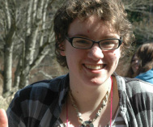
Co-YAC Social Action Coordinator (SAC) and Technological Advancement Squad Leader: Kaylyn Olynyk of CVUF, Comox, BC
Kaylyn is in grade 12 and she is most passionate about the written word including but not limited to fiction, political rants, music lyrics, tv/movie scripts, and anything else you can think of. She also loves to write. Kaylyn describes herself an an introvert, and a word nerd, having a deep love for language, stories, puns, and creation. She finds the escapism of making up a story or losing yourself in someone else's mesmerizing. Kaylyn joined the BC YAC because she wanted to stay connected to the awesome community of people she met at the RFG (see conferences). What she enjoys most about BC YAC, other than being connected, is working together towards something different from anything she's ever worked on before, and something she knows will be fantastic. Kaylyn joined the BC YAC in 2011.

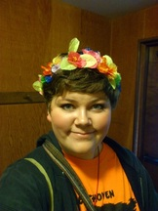
Scribe: Zoë Brimacombe of FUCV, Victoria, BC
Zoë is in 10th grade and is passionate about many things in life, specifically obsessed with acting. She started doing improv at the tender age of 6, and has been involved in professional stage shows for the last 5 years! Theatre shows her more about herself than any other activity and forces her to examine simple things such as breathing, speaking, walking. She also loves to write short stories and plays and is a very accomplish playwright, her play "Shadows" was a winner of the Young Playwright's festival in 2011. She loves the effect words can have on people. Zoë loves the BC YAC because it gives her the chance to stay in touch with all the wonderful UU youth in BC, and enjoys planning conferences, namely Spring Con 2012 (a conference of over 200 people). She considers BC YAC to be one of the most welcoming and dynamic communities that she's ever been a part of and she's honoured to be a part of it. Zoë joined the BC YAC in 2011.

Co-Newsletter Editor and Treasurer: Elijah Marrett-Hitch of FUCV, Victoria, BC
Elijah is in 10th grade and he is most passionate about music. He believes it brings people together, and it has been a part of his life for a really long time. Elijah plays accordion, violin, and piano among other things and has graced us with his amazing skills many a time. Elijah joined BC YAC because he was interested in learned more about what Unitarian youth do, and he loves working with all the amazing people on our committee. Elijah joined the BC YAC in 2011.

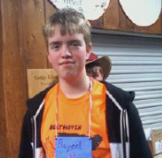
Co-YAC Social Action Coordinator (SAC) and Technological Advancement Squad Leader : Rupert Gomery of UCV, Vancouver, BC
Rupert Gomery is a grade 11 student, although he tends to find himself wishing he could just skip to university. He is most passionate about people, all of those around me who I interact with. It really makes him the odd one out in my family; while everyone else needs quiet time alone from time to time, he finds it draining. That’s the reason he joined the BCYAC, he saw this awesome group of youth come to his church to hold a conference and they said that they needed to elect new members and he thought, “I could do that”. He's not always the most organized but it has been the best experience to work with them the past two years.

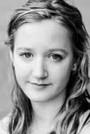
Y.E.S. Representative: Jamie van Gessel, FUCV, Victoria, BC
Jamie is a grade 10 student who has a passion for performing and creating. Sharing who she is with the world is how she gets her kicks and being able to show people what she can do and being able to influence someone's reactions makes her happy. She's been performing since before she can remember and it will always be a huge part of who she is. Likewise with creating, there's something for her about being able to say "I made that" or "I wrote that, sang that, danced that, finger-painted that." Jamie joined the BC YAC because she loves leading, and creating awesome things with awesome people. One of the biggest pulls for her were the people on it- youth and adults who are currently doing amazing things and will continue on to do amazing things. She loves what we create together, as a group of people working together on what we care about.

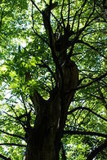
BC YAC Adult Support and Ally: Kimberly Bramadat of FUCV, Brentwood Bay, BC
Kimberly is passionate about how everyone is all connected as a working unit, including sunsets, smiles, organic food, recycling, giggles from animals and people, and the bending of trees in the wind. She is also incredibly passionate about being a grounded resource to both the youth of the BC YAC and of the FUCV, where she acts as a youth adviser. She strives to be a full part of her darling daughter's life, and a valuable partner in her significant relationship with her fiancé. Kimberly joined BC YAC to support the creative process of discovering and uncovering the limitless possibilities in life that connect and unite the youth with the world. She treaures her experience with the youth, finding the ideas they share to be insightful and refreshing. Kimberly joined the BC YAC in 2011.

CUC National Youth and Young Adult Programming: Ariel Hunt-Brondwin of UCV, Vancouver, BC
Ariel is incredibly passionate about her job. Her work lets her feel like she is making a really positive difference in the lives of the people she works with and for the Unitarian tradition in Canada through working for the CUC. Sometimes that looks like her being a bit of a work-aholic but on her best days she feels like in some small ways that she is able to help youth and young adults and their allies gain a more enriching and spiritually fulfilling experience in their church and in their UU faith and she believes that is truly gratifying. Ariel is not technically a BC YAC member but she supports the BC YAC because she believes in the power of youth to minister each other through mentoring each other in leadership and by creating amazing, inclusive, worshipful conference communities. What she enjoys the most is watching the incredibly organic and creative way BC YAC members work and learn together. Ariel began her support of the BC YAC in 2011.

THANKS FOR READING
-FIN-

